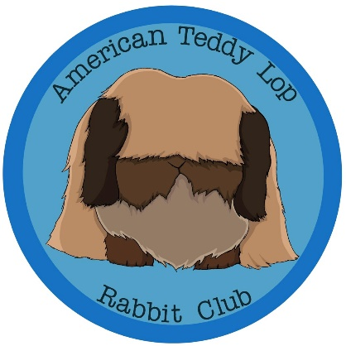

2023 ARBA Draft Teddy Lop Standard of Perfection

General Type ………………. 50 Body……………….………. 20 Head………………….……. 10 Ears………………….……….10 Eyes…………………………. 5 Feet leg and bone.…. 5 Wool……………………………. 40 Density……….…………. 15 Texture……….………… 15 Length……………………. 10 Markings & Color……. 5 Condition………………... 5 Total Points…………………. 100 Showroom classes & weights senior bucks – 6 months of age, not over 4 pounds senior does – 6 months of age, not over 4 pounds Junior Bucks and Does – under 6 months of age, not over 3 ½ pounds Minimum weight – 1 pound 14 oz Note: No animal may be shown in a higher age classification than its true age. No animal may be shown in a lower age classification than its true age. Teddy Lops are to be posed down. The back feet are to be placed directly under the point of the hip and the head positioned near the body. General Type (points 50) Body (points 20): The body is to be short and close- coupled, with the full chest and round shoulders, to balance with the hips. Depth of the body should be approximately equal to the width with the midsection well filled. The hind quarters should be smooth and slightly wider than the shoulders. The topline should rise slightly from a strong shoulder rounding in a smooth curve to the base of the tail. The animal should be well nourished, compact, and balanced. Faults: Body lacking depth; long, low or narrow shoulders, chopped pinched or undercut hindquarters, dewlap in does.

Head (Points 15): The head is to be oval, but not pear shaped or having a pointed muzzle. The head should be broad across the forehead and slightly narrower at the muzzle, to balance with the size on the crown, muzzle, and cheeks. Full facial wool. Faults: Short. Blocky head; sparse or unevenly distributed head furnishings. Ears (points 15): The ears should hang close to the cheeks from a strongly defined and properly positioned crown. The ears should be thick well-rounded at the tip and densely covered in wool furnishings. Wool furnishings should be balanced on both ears. Ears should be positioned just behind the eyes. Length of ears should be slightly longer than the jaw line, not to exceed 1 1/2 inch. Ears should be balanced with the size of the head. Faults: Thin, narrow ear openings; overly narrow, pointed, folded or poorly wooled ears; ear length too short or long so it does not balance with the size of the head; slipped crown; uneven length or distribution of wool furnishings on ears. Eyes (points 5): The eyes should be bold, bright, and deep set. Faults: Eyesight of animal overly obscured by wool furnishings. Feet, leg, and bone (Points 5): The legs are to be short and straight, medium in bone, and have the proper length and size to balance and harmonize with the compact body. Legs are to be well covered with decent quality wool, free from mats, extending well out to the extreme end of the toes. Feet should have thick, heavy foot pads. Toenails on colored and pointed white animals are to be colored, and to match to the same foot and corresponding foot. Toenails on white animals are to be white. Faults: Extremely fine bones and lack of wool furnishings that do not extend to the full length of the leg. Disqualifications from competition: Unmatched toenails on same foot or corresponding foot. (Per general ARBA disqualifications.) Wool (points40) Density (Points 15) Wool should be dense and even all over the animal. A double main should be draping around the head and neck. The double mane should be well blended into the coat. Faults: Matted wool. Bare spots. Wool that is sparse and unevenly distributed across the animal including saddles. Texture (Points 15): The wool should be slightly coarse in nature. Wool should be full of life and well distributed with guard hairs; not to be overly soft, cottony, felting type wool. Softer wool is permissible in juniors. Disqualifications from competition: Wool that is excessively coarse. Underwool is not permissible. Length (Points 10): Length is to be uniform all over the body. Wool should ideally be between 3 and 4 inches in length. Wool exceeding 4 inches is not to be given any advantage. Evenness of growth of wool is desired with a permissible decrease in length on the underside of the animal. Decreasing length of facial wool is permissible and to be well groomed and maintained. Faults: Wool not uniform in length. Webbed, matted, felted, listless, soft, or packing. Color & Markings (Points 5): Per approved ARBA colors. Eyes – To match description in list of recognized Teddy Lop colors.
Faults: Uneven color; washed out, faded, or shallow color. Color not carried down to the skin (except in colors allowing white under color). Stained coat. Eyes that are pale in color. Condition (points 5): Per ARBA definition.

